There are two users for testing plugin:

* Admin
* Pm (Project-manager)

1. **Testing plugin availability for users**

Pm user:

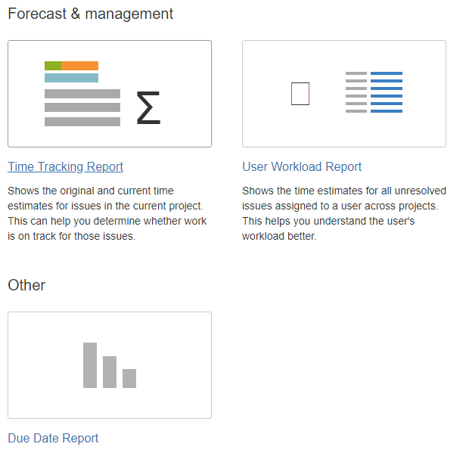

Admin user:

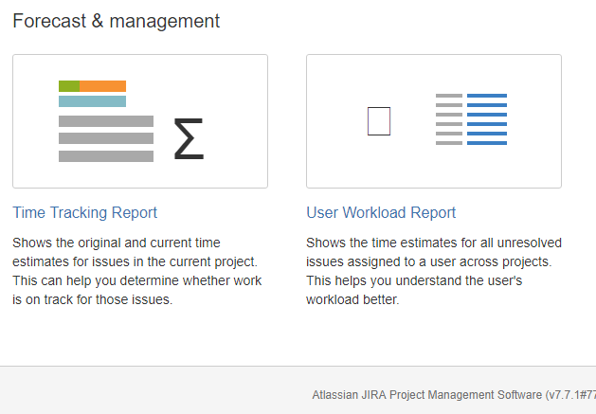

1. **Testing report plugin functionality**

Test data: there are several issues in Test Project with due dates:

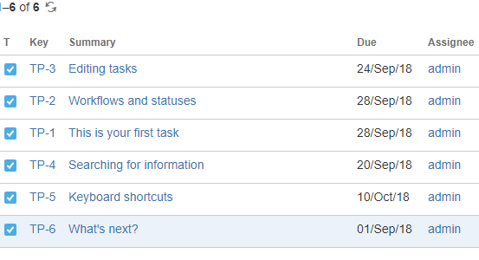

2.1 Test case with filled due date field

Go to report plugin and fill “Due date” field: 30/sep/18

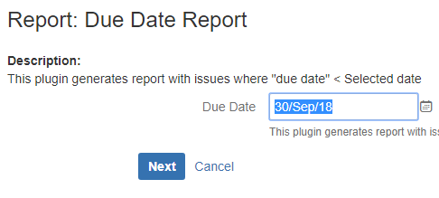

Press next:

There is table containing three issues with “due date” < 30/sep/2018

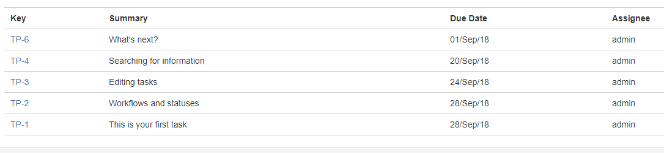

* 1. Test case with empty due date field

